

Department | FED
Subject | DSA-2
Academic Year | Ⅰ-Ⅲ Semester(2025-26)
Faculty Name | Ms. Alluri Swathi
Student Name | Boddapati Himavanth Sai Ganesh
Roll Number | 2520030429
Branch | CSE
Course Outcome | 1

Case Study Topic: EduGraph Adaptive Course Recommendation System using BST & AVL Tree
Work Done Summary:
The application of Binary Search Trees (BST) and AVL Trees in managing hierarchical educational datasets efficiently. An Adaptive Learning & Course Recommendation System was developed where course records are stored, inserted, searched, and deleted using tree data structures to provide faster and optimized course recommendations for students.
Implementation Details:
- Created BST and AVL Node classes with fields: courseId, courseName, category, rating, left, right, and height.
- insert() method recursively inserts new course records into BST and AVL Trees.
- search() method retrieves course details quickly using Course ID.
- delete() method removes outdated or inactive course records while maintaining tree structure.
- inorderTraversal() displays all available courses in sorted order based on Course ID.
- balanceFactor() calculates the height difference between left and right subtrees in AVL Tree.
- rotateLeft() and rotateRight() methods perform AVL balancing operations after insertion and deletion.
- comparePerformance() analyzes BST and AVL efficiency based on insertion, deletion, and searching operations.
- displayCourses() module prints complete course details including Course ID, Course Name, Category, and Rating.
- Main method demonstrated course insertion, searching, deletion, AVL balancing, traversal operations, and performance comparison for adaptive course recommendation.

Result: Screenshots/Output
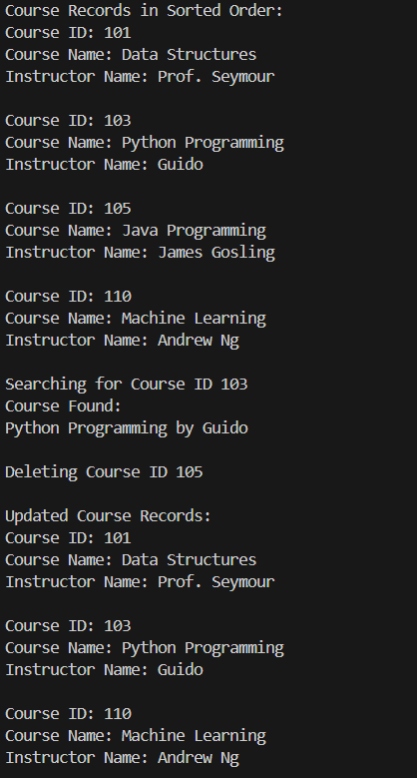
• Successfully inserted and managed course records.
• AVL Tree maintained balanced structure after multiple insertions and deletions.
• Faster course searching and recommendation retrieval observed in AVL Tree compared to normal BST.
• Sorted course listing generated using inorder traversal.

Time Complexity Analysis
• BST Insert/Delete/Search: O(log n) (average case)
• AVL Tree Insert/Delete/Search: O(log n) due to self-balancing property
• Inorder Traversal: O(n)
• Rotation Operations in AVL Tree: O(1)
• Compared to traditional array/list searching O(n), BST and AVL Trees provide faster searching and efficient management for large-scale educational course datasets.

GitHub Link: https://github.com/himavanthsaiganesh/DSA2-CASE-STUDY-CO---1

Student Signature | Faculty Signature

